SECTION A: Multiple-choice questions

Question 8
The waste water from a chemical plant was found to contain NaOH at a concentration of 0.10 M. What volume of 0.01 M HCl solution would be required to neutralize 1000L of the waste water?
- 10000L and the concentration of the hydroxide ions would decrease and the pH would increase.
- 10000L and the concentration of the hydroxide ions would decrease and the pH would decrease.
- 1000L and the concentration of the hydrogen ions would decrease and the pH would increase.
- 1000L and the concentration of the hydrogen ions would increase and the pH would increase.

NaOH(aq) + HCl(aq) → NaCl(aq) + H₂O(l)
0.10M 0.01M

n(NaOH) = c x V = 0.10 x 1000 = 100mol = n(OH⁻)
Since neutralization : OH⁻ (aq) + H⁺(aq) → H₂O(l)

n(OH⁻) = n(H⁺) = n(HCl) = 100 mol
n(HCl) = c x V
100 = 0.01 x V
V(HCl) = 100/0.01 = 10,000L
Since the waste water initially contained OH⁻, the hydroxide ion concentration would decrease with the addition of the hydrochloric acid and the pH of the solution would decrease.

Answer: B

Questions 9, 10 and 11 refer to the following information.

The caffeine content of two brands of coffee was tested using high pressure liquid chromatography (HPLC). One brand being tested was an instant coffee, while the other was decaffeinated. The following results were obtained.

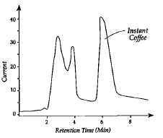

Caffeine Standard
Instant Coffee

Current
Current

Retention Time (min)

Retention Time (min)

Decaffeinated Coffee

Current

Retention Time (min)

Question 9
The retention time measured for caffeine in the tests above is a measure of:
- The time taken to inject the sample of coffee into the instrument.
- The time required for the solvent to move through the instrument.
- The time it takes caffeine to pass through the column in the instrument.
- The amount of caffeine in the sample.

Answer : C

Question 10
The results obtained indicate that:
- The retention time for caffeine is two minutes.
- The brand of decaffeinated coffee still contains large quantities of caffeine.
- The amount of caffeine in the instant coffee is negligible.
- The amount of caffeine in the decaffeinated coffee is negligible.

Answer : D

Question 11
Another brand of coffee was found to contain 4.0% by mass of caffeine. If 2.0 g of this product is used to make a 150 mL cup of coffee, then the concentration of caffeine in the coffee cup would be:
[M (caffeine) = 194 g mol⁻¹]
- 0.0027 M
- 0.27 M
- 0.010 M
- 0.069 M

Since we have been told 4.0% by mass of caffeine in the sample, then in this 2.0g product we would have:
2.0 x$\frac{4.0}{100}$ = 0.080g in the 2.0g of the sample
As the 2.0g was dissolved in 150mL water: we have 0.080g in 150mL cup of coffee.

n(caffeine) = $\frac{m}{M}$ = $\frac{0.080}{194}$ = 4.124 x10⁻⁴ mol

C= $\frac{n}{V}$ = $\frac{4.124 x{10}^{-4} mol}{0.150}$ = 2.749 x 10⁻³ = 0.002749 = 0.0027M

Answer : A

SECTION B

Question 1 (5 marks)
Sodium thiosulfate (Na₂S₂O₃), has been used to treat people with kidney disease.
It is useful in analytical chemistry because the thiosulfate ion, S₂O₃²⁻ reacts with iodine, I₂ in aqueous solution, reducing it to iodide, I⁻ as it is oxidized to persulfate ion, S₂O₈²⁻.

        - Write the half equation that represents the reduction process in this reaction.
I₂(aq) + 2e → 2I⁻ (aq) (1 mark)

___________________________________________________________________________
(1 mark)

        - Write the half equation that represents the oxidation process in this reaction.

S₂O₃ ²⁻ (aq) + 5H₂O(l) → S₂O₈ ²⁻(aq) + 10H⁺(aq) + 10e⁻

(1 mark)

___________________________________________________________________________
(1 mark)

        - Determine the overall reaction between the thiosulfate ion and iodine. Include states.

S₂O₃ ²⁻ (aq) + 5H₂O(l) + 5I₂(aq) → S₂O₈ ²⁻(aq) + 10H⁺(aq) + 10I⁻ (aq)

(1 mark)
(1 mark for states)

___________________________________________________________________________
(2 marks)

        - Identify the oxidation number of sulfur in the thiosulfate ion.
2(+2) 3(-2) = -2
S₂ O₃ ²⁻

Oxidation number of S is +2. (1 mark)

___________________________________________________________________________

(1 mark)
Question 3 (14 marks)

Tartaric acid (H₂C₄H₄O₆) makes up a major proportion of the total acid content of wine.

A 750 mL bottle of wine was tested for its tartaric acid content. A 20.00 ml aliquot of the wine was reacted with 10.00 mL of a 0.360 M sodium hydroxide solution. The following reaction occurred:

H₂C₄H₄O₆(aq) + 2NaOH(aq) → Na₂C₄H₄O₆(aq) + 2H₂O(l)

The excess sodium hydroxide solution required a 17.40 mL titre of 0.115 M hydrochloric acid standard to neutralize it according to the equation:

NaOH(aq) + HCl(aq) → NaCl(aq) + H₂O(l)

- Write an ionic equation for the neutralization of the excess sodium hydroxide with hydrochloric acid.

OH⁻ (aq) + H⁺ (aq) → H₂O (l) (1 mark)
_______________________________________________________________________________________
(1 mark)

- Calculate the amount, in mole, of the hydrochloric acid which was used in the titration.
n(HCl) = c x V = 0.115 x 0.0174 = 0.00200mol (1 mark)
(1 mark)

- Determine the amount, in mole, of the sodium hydroxide which reacted with the hydrochloric acid.

Since, NaOH : HCl is 1: 1
n(NaOH) = 0.00200mol (1 mark)

_______________________________________________________________________________________
(1 mark)

- Calculate the number of mole of sodium hydroxide which reacted with the tartaric acid in the wine.

n(NaOH) excess from reaction 1 = n(NaOH) reacted with HCl = 0.00200mol

n(NaOH)total = 0.010 x 0.360 = 0.00360mol (1 mark)

n(NaOH) reacting with tartaric acid = n(NaOH)total – n(NaOH)excess from reaction 1
= 0.00360 - 0.00200
= 0.00160mol (1 mark)

(2 marks)

- Calculate the mass of tartaric acid in the 20.00 mL aliquot.

From equ 1 H₂C₄H₄O₆ : NaOH
1 : 2
n(H₂C₄H₄O₆) = ½ x n(NaOH)
= ½ x 0.00160
= 0.000800mol (1 mark)

Mass(H₂C₄H₄O₆) = n x M
= 0.000800 x 150
= 0.120g in the 20.00mL aliquot of wine. (1 mark)
(2 marks)

- Calculate the mass of tartaric acid in the 750 mL bottle of wine.

By proportions: 0.120g tartaric acid in the 20.00mL aliquot
Xg tartaric acid in the 750mL bottle of wine

X = $\frac{0.120 ×750}{20.00}$ = 4.50g (1 mark)
(1 mark)
- Draw a pH curve for the titration between the sodium hydroxide, NaOH and hydrochloric acid, HCl. Include all relevant information in your graph.
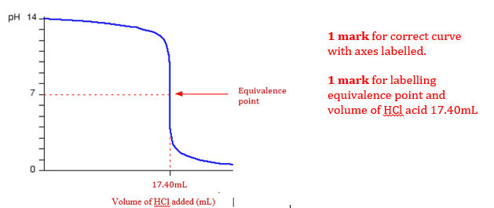
( 2 marks)
- Choose a suitable indicator for the reaction between the excess sodium hydroxide and the hydrochloric acid and provide a reason for your choice.

Possible indicators to use : Bromothymol blue(6.0-7.6)
phenol red(6.8-8.4)
phenolphthalein(8.3-10.0)
Any one of these for 1 mark.
The best one to use would be Bromothymol blue.

The indicators would change colour at the equivalence point of titration to detect that the end point has been reached. (1 mark)
(Phenolphthalein is the most popular indicator to use as it will still give us a colour change as the solutions are not too diluted i.e 0.0001M)
(2 marks)
- Sodium hydroxide solution should not be left standing as it reacts with carbon dioxide in the air. Explain the effect on the calculated value for the acidity of wine if the solution of sodium hydroxide had been left in an open bottle for a couple of days before adding it to the wine.

(NaOH reacts with carbon dioxide in air causing a change in concentration.)

The concentration of NaOH would be lower as the NaOH would have reacted with the carbon dioxide in the air. This would result in less mole NaOH to be present to react with the HCl in the second reaction. Therefore less Volume (titre) of HCl would be required. (1 mark)

More n(NaOH) though to react with the tartaric acid in reaction 1. Then more tartaric acid thought to be present in the wine sample. This would result in a greater value of mass of tartaric acid in the wine and the result would be overestimated. (1 mark)

(2 marks)

SECTION A: Multiple-choice questions

Question 1
There are four different proton environments in 1-propanol. The diagram below labels two of these proton environments.
I II
$${CH}_{3}-{CH}_{2}-{CH}_{2}-OH$$

In the ¹H NMR spectrum of 1-propanol, the proton environments labelled as I and II will appear as:

- I: triplet at 0.8-1.0 ppm II: quartet at 3.3-4.5 ppm
- I: quartet at 0.8-1.0 ppm II: triplet at 3.3-4.5 ppm
- I: triplet at 0.8-1.0 ppm II: triplet at 3.3-4.5 ppm
- I: triplet at 3.3-4.5 ppm II: quartet at 0.8-1.0 ppm

Question 2
An alkanol has the molecular formula C₄H₁₀O. Its ¹³C NMR spectrum consists of four signals. Which of the structures below is consistent with this information?

- CH₃CH₂CH₂CH₂OH
- CH₃CH₂CH(OH)CH₃
- CH₃CH(CH₃)CH₂OH
- CH₃CH₂CH₂OH

Question 3
Which of the following spectroscopic techniques (I – V) result in the excitation of electrons?
I UV-visible spectroscopy | II Atomic Absorption Spectroscopy | III Mass spectrometry
IV NMR spectroscopy | V IR Spectroscopy

- I and II
- III and IV
- I and V
- IV and V

Question 4
Parent molecular ion
X
The mass spectrum of ethanoic acid is shown above. The parent molecular ion (m/z = 60) has the formula CH₃COOH⁺. When this ion breaks up, other fragments are produced.
The peak labelled ‘X’ occurs at m/z = 43. Which of the following fragments could have been lost from the parent molecular ion to produce this peak?

- OH∙
- OH⁺
- CH₃∙
- CH₃⁺

Question 5
A Chemist wants to determine if an unlabeled bottle contains 1-propanol or 2-propanol. Which one of the analytical techniques below would be the best suited to identify the alkanol if there were no standards available?

- UV-visible spectroscopy
- IR spectroscopy
- Atomic absorption spectroscopy
- ¹H NMR spectroscopy

Question 6
Compound 1 | Compound 2
The two compounds shown above are correctly named as:

Compound 1 Compound 2
- 2-methylbutan-2-ol 3-methylbutan-2-amine
- 2-methylbutan-2-ol 2-methylbutan-3-amine
- 1,1-dimethylprop-1-ol 3-methylbutan-2-amine
- 1,1-dimethylprop-1-ol 2-methylbutan-3-amine

Question 7
A compound has the molecular formula C₃H₆X. The atom X is most likely to be:

- hydrogen
- nitrogen
- oxygen
- chlorine

Question 8
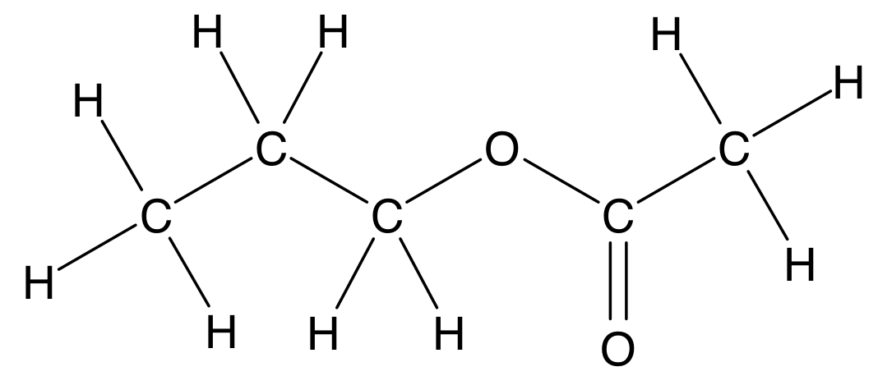
The ester shown above was most likely made from the following compounds:

- propanoic acid and ethanol
- ethanoic acid and 1-propanol
- propanoic acid and 1-propanol
- ethanoic acid and ethanol

SECTION B

Question 1 (18 marks)
Esters are responsible for some of the natural and synthetic flavours and smells in sweets. The table below shows three different esters commonly used in a sweets factory.

- Complete the missing semi-structural formulas and systematic names for the esters listed in the table below.

Ester | Semi-structural formula | Smell or flavour
Pentyl butanoate | CH₃CH₂CH₂COOCH₂CH₂CH₂CH₂CH₃ | Pear
Ethyl pentanoate | CH₃CH₂CH₂CH₂COOCH₂CH₃ | Apple
Butyl pentanoate | CH₃CH₂CH₂CH₂COOCH₂CH₂CH₂CH₃ | Raspberry
(3 marks)

- The production manager suspects that the three different esters listed in the table above (Q1a.) have been labelled incorrectly. A ¹H-NMR analysis of one of the samples is shown below.

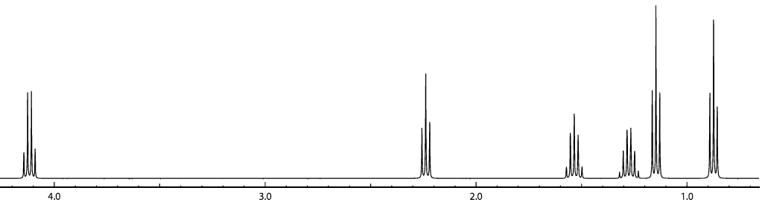
Peak A
Peak B
Chemical Shift (ppm)

- How many different chemical environments can be seen in this ¹H-NMR spectrum?
Six

- Which of the three esters listed above (Q1a.) is the one responsible for this ¹H-NMR spectrum?
Ethyl pentanoate or structural formula or consequential to the Name in 1a

- Draw the structural formula of this ester.

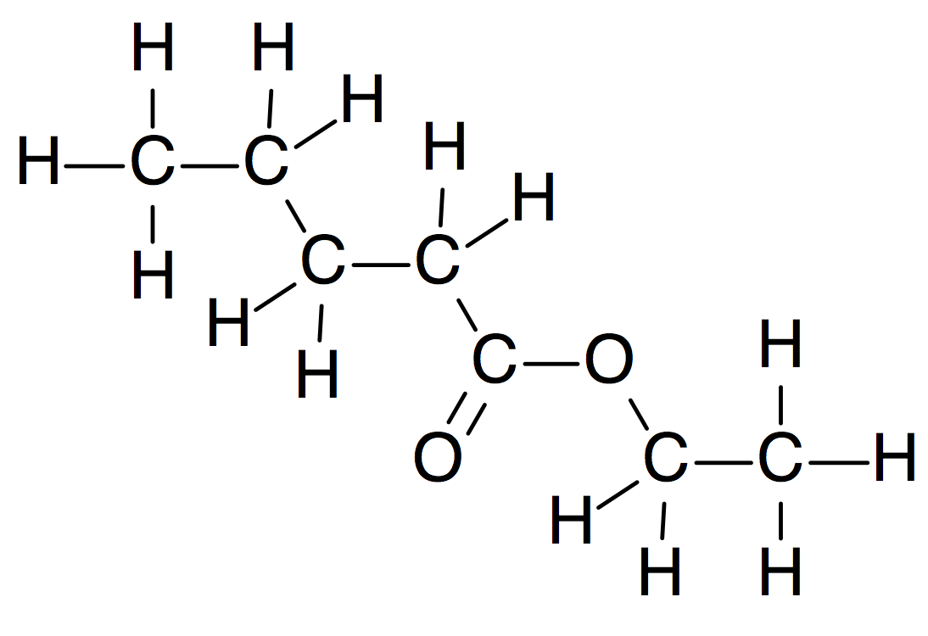
B (must be labelled)
A

- In the structure drawn above (Q1b. iii), circle and label the hydrogens responsible for Peak A (1m) and Peak B (1m) shown on ¹H-NMR spectrum in (Q1b.). Explain below:

The splitting pattern of Peak A: It has three neighbouring H, therefore appears as a quartet (1m)
Why Peak A appears further downfield than Peak B:
Because hydrogens in Peak A are less shielded
or have a neighbouring O atom which attracts electrons and results in deshielding (1m).

- Apart from ¹H-NMR spectroscopy, what other spectroscopic technique could you use to clearly identify the ester in the sample? Explain your answer.
Mass spectroscopy (1 mark) : compare fragmentation pattern to standards (1 mark)
IR (1 mark) : compare fingerprint region to standards (1 mark)
(1 + 1 + 1 + 4 + 2 = 9 marks)

- The production manager wants to introduce a new banana flavour, given by the ester butyl ethanoate. Complete the organic pathway below to show how butyl ethanoate could be synthesised.
(6 marks)

butane
Compound A
Structural formula:
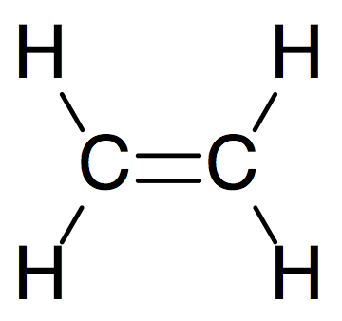

Conditions II: Cl₂/UV

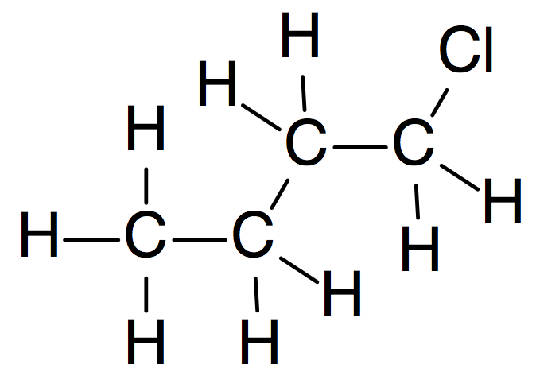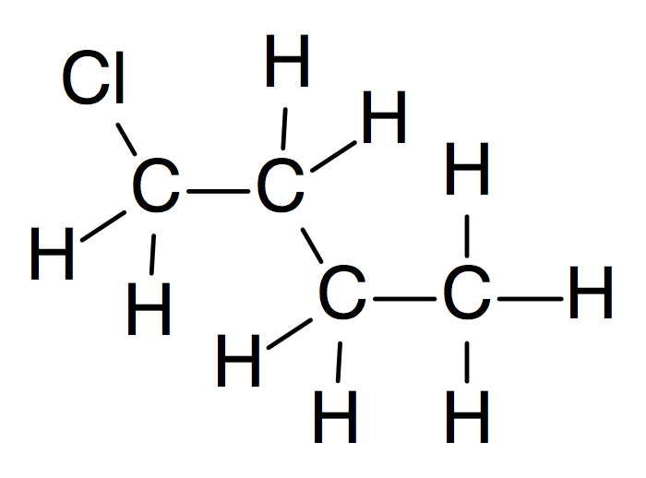

H2O / H3PO(s) / heat

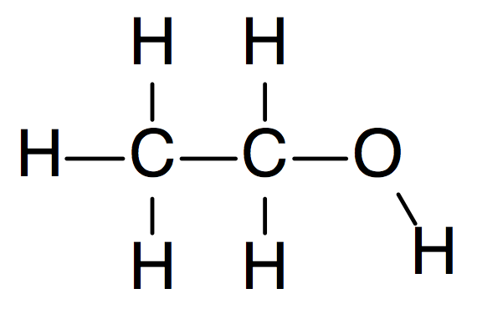

NaOH(aq)

Compound C
Semi-structural formula:

CH₃CH₂CH₂CH₂OH

Conditions I: Cr₂O₇⁻/H⁺ or MnO₄⁻/H⁺ (No O₂)

Compound B
Name: ethanoic acid
Or acetic acid

Conditions III: conc H₂SO₄ (or liquid)

Butyl etanoate

- Draw the structural formula of Compound A in the box provided 1 mark
- Write the systematic name of Compound B in the box provided. 1 mark
- Write the semi-structural formula of Compound C in the box provided. 1 mark
- Write the Conditions required for reactions I, II and III 3 marks

Question 3 (8 marks)
Bioethanol is a readily available, clean fuel for combustion engines.

- Why is bioethanol considered to be a renewable energy source?
Because it is produced from plants, which are resources that can be naturally replenished in a short time.
(1 mark)

- Write the fully balanced equation for the fermentation process that converts glucose (C₆H₁₂O₆) to ethanol.
C₆H₁₂O₆ (aq) → 2 CH₃CH₂OH (aq) + 2 CO₂ (g)
(2 marks)
(1 mark for states, 1 mark for balanced equation)

- Ethanol can be reacted with fatty acids to make biodiesel in an esterification reaction. The mass spectrum below corresponds to a biodiesel produced by this type of esterification reaction.

- What is the molar mass of the ester?
284 g/mol
(with correct units)
(1 mark)

- Which fatty acid was reacted with ethanol to produce this compound? Refer to the Data Book and show your workings.
M(Ethanol)= 46 g/mol
M(H₂O)= 18 g/mol

Ester = M(Ethanol) + M(fatty acid) – M(H₂O)

M(fatty acid)= 284g – 46g + 18g = 256 g/mol (1 mark)

Therefore, it must be palmitic acid (from DB) (1 mark)
(2 marks)

- Write a fully balanced chemical equation for the esterification reaction between ethanol and the fatty acid identified in question above (Q3c. ii).
C₁₅H₃₁COOH + CH₃CH₂OH → C₁₅H₃₁COOCH₂CH₃ + H₂O
(1 mark)

- Write the chemical formula for the ion responsible for the peak at m/z = 255.
C₁₅H₃₁COO+
(1 mark)

